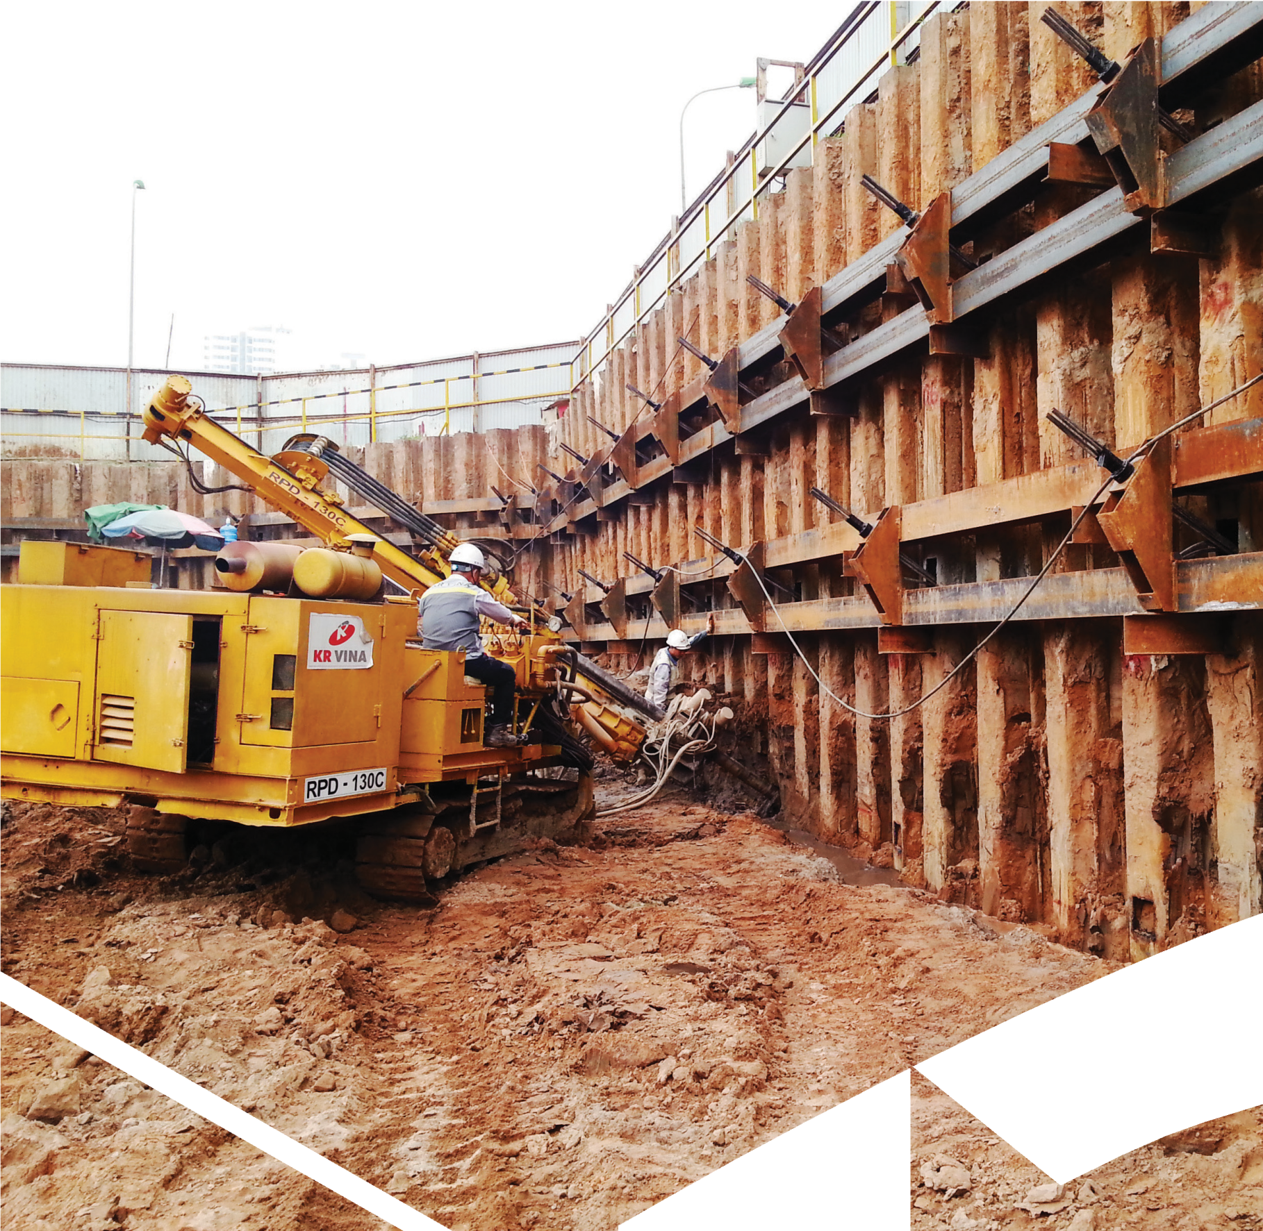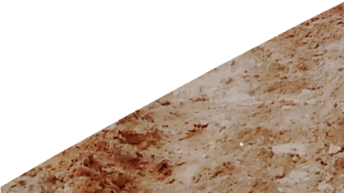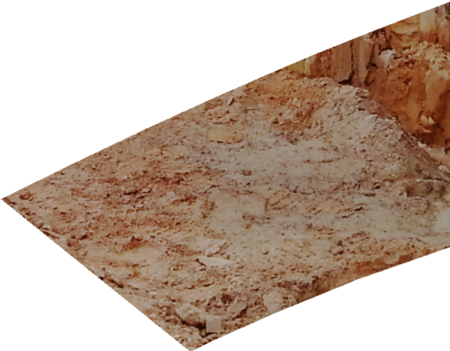

KR VINA

KR VINA Co., Ltd
Ground Anchor, Jet Grouting, Micro piles, Steel Structure
P R O F I L E

General Director
RA JUNG HYUN

General Manager
KANG JANG KUK
General Manager Oversea
CHOI KYUNG DONG
YOO KAWN CHUL

Managing Department NGUYEN THI ANH KIM

Construction Department KWON OH SUK

Plan department LE THANH SON

Accountant

Construction Team NGUYEN QUANG HUYEN

Construction Team NGUYEN CAO CUONG

Oversea Construction Team
CHOE KI CHOL
Project Team

Personnel

Quality control

Ground Anchor

Grouting, bore piling

Ground Anchor, Grouting, Steel structure
Tender /contract

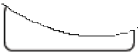Administration
ORGANIZATION CHART

Material Control

Equipment Control

Equipment Control
Equipment: mobilize from Vietnam
or renting oversea

Resource Control

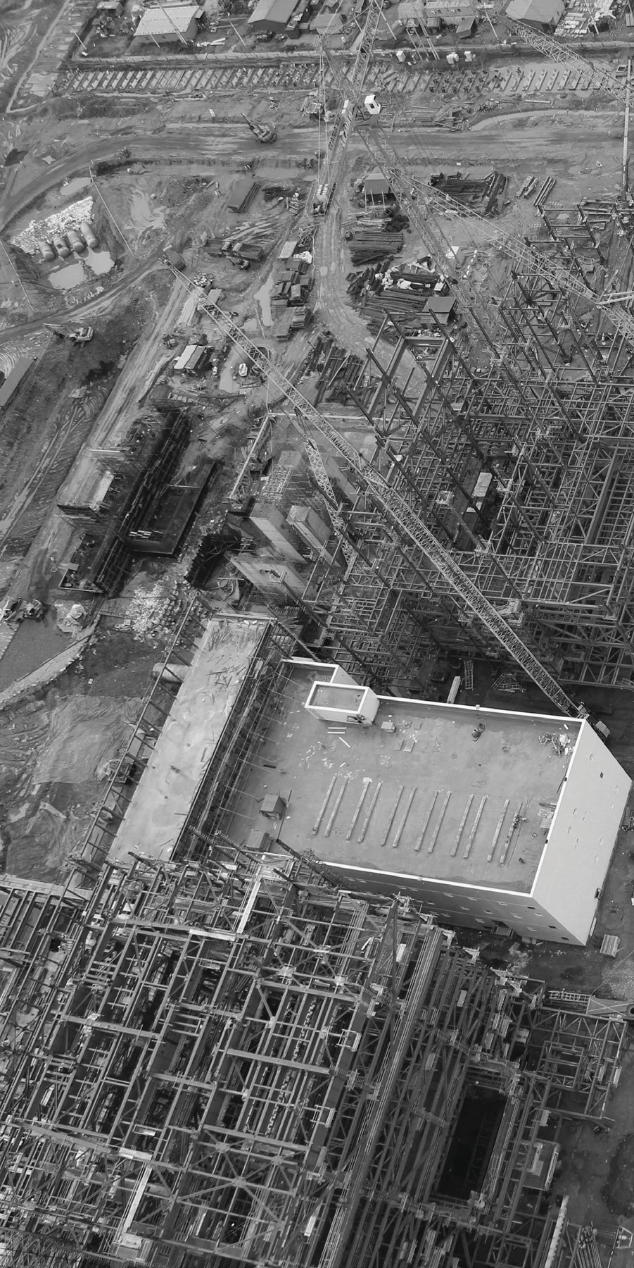ABOUT US
Name of Company: KR VINA CO., LTD. General Director: RA JUNG HYUN
2nE Floor, Vimeco building, Lot E9, Pham Hung Road, Trung Hoa Ward, Cau Giay Dist, Ha Noi, Viet Nam
Tel: +84 24 6674 1569 (H/P: 0985 280 262)
Website: www.krvina.com
E-mail: krvina09@gmail.com

Tax-code: 0104254619
Business Registration Number: 011023000199

Executing business with passion for work and cooperation.

VISION
Based on the technology, experiences and passion in works, we work the best for Customers

STRATEGY
Management control system of procedure including Planning, Drawing, Production and Construction.

MISSION
Cost reduction through new technology Quality control through following principle execute in the date custom ers need.

ABOUT US
CERTIFICATE OF REGISTRATION
License of KRVina Co., Ltd

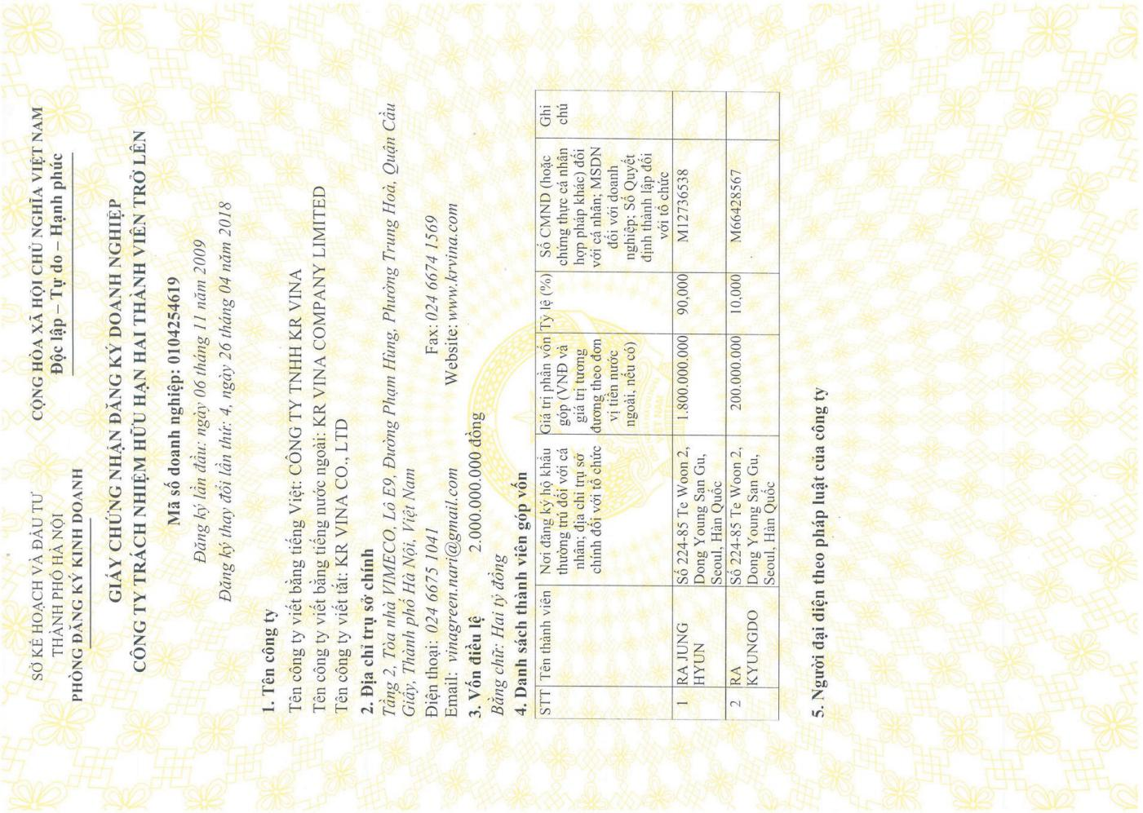

EQUIPMENT RESOURCE
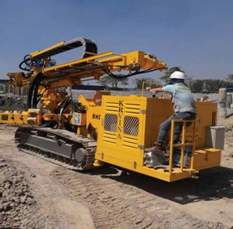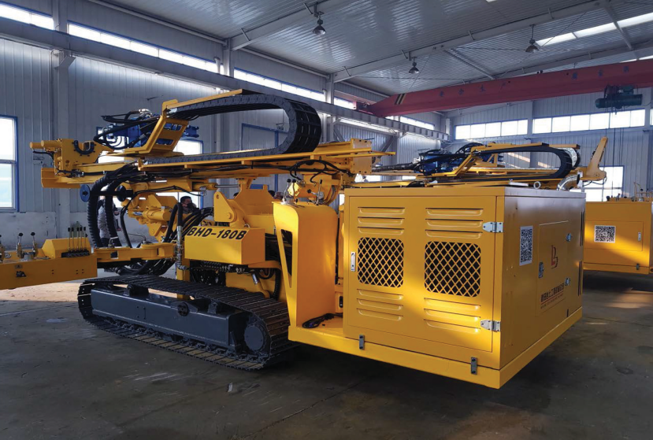

1. DRILLING MACHINE
MODEL: BHD-215 TYPE : HYDRAULIC BRAND : BEALONG PRO-YEAR : 2018 WEIGHT : 14 Ton
PILE SIZE : 133~146mm (GA), 200~300mm (MP).
DRILLING DEPTH, MAX: 150 mm WORKS: G/A, MICRO PILE.

2. DRILLING MACHINE
MODEL: BHD-180B TYPE : HYDRAULIC BRAND : BEALONG PRO-YEAR : 2018 WEIGHT : 14,7 Ton
PILE SIZE : 133~146mm (GA), 200~300mm (MP).
DRILLING DEPTH, MAX: 150 mm WORKS: G/A, MICRO PILE.
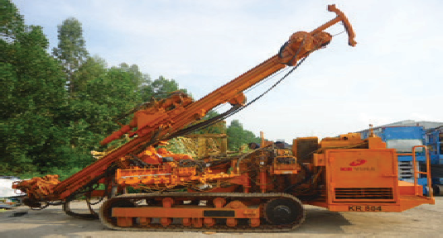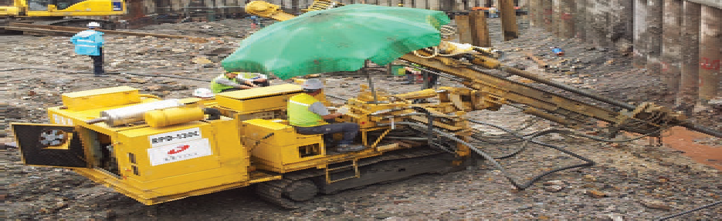

3. GROUTING MACHINE
MODEL: KR-804 TYPE : HYDRAULIC
MAKER : GERMANY KLEMM PRO-YEAR : 2003
WEIGHT : 13 Ton
PILE SIZE : 73~200mm
WORKS: JET GROUTING, G / A, MICRO PILE

4. DRILLING MACHINE
MODEL: RPD-130, RPD-100
TYPE : HYDRAULIC
QUANTITY : 2 units
MAKER : KOKEN
PRO-YEAR : 2008
WEIGHT : 10 Ton
PILE SIZE :73~200mm
WORKS : G/ A, MICRO PILE

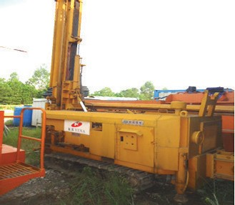

5. GROUTING MACHINE
MODEL: MK2 TYPE : HYDRAULIC MAKER : MINWAN PRO-YEAR : 2004
WEIGHT : 11.8 Ton PILE SIZE :73~200mm
WORKS : LW GROUTING, JSP GROUTING, MICRO PILE

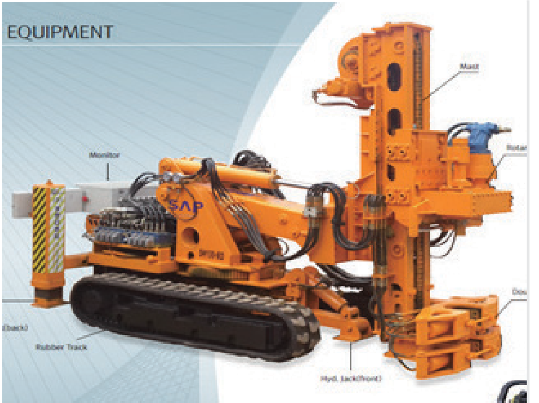

6. DRILLING MACHINE
TYPE : HYDRAULIC MAKER : KOREA PRO-YEAR : 2014 WEIGHT : 10.5 Ton
MAXIMUM PILE SIZE : 72~180mm WORKS : G/ A, MICRO PILE

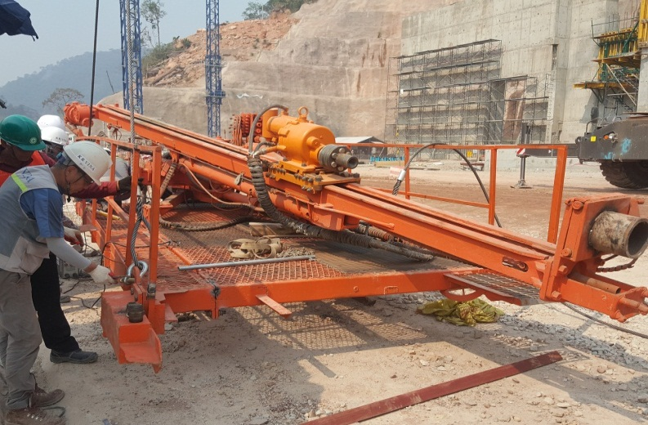
7. SKY DRILLING MACHINE
MODEL: GT-200
TYPE : HYDRAULIC
QUANTITY : 1 units
MAKER : GT INDUSSTRY
PRO-YEAR : 2014
WEIGHT : 6.5 Ton
PILE SIZE :73~220mm WORKS : SLOPE ANCHOR

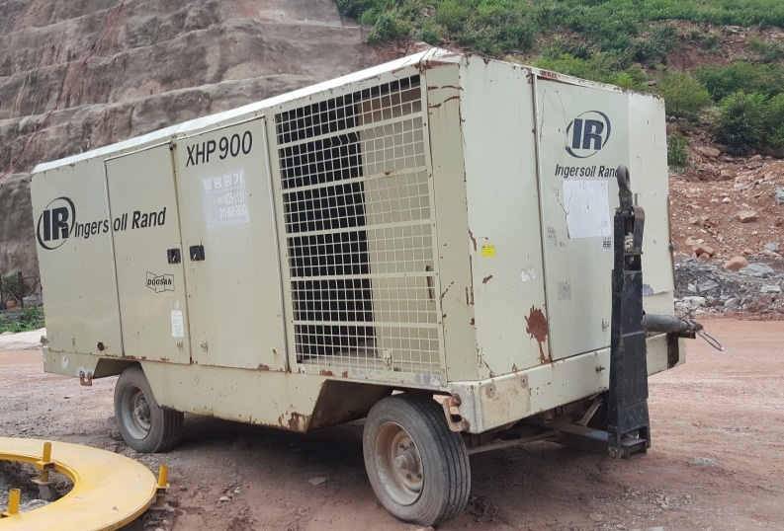

8. AIR COMPRESSOR
MODEL: XHP 900 (Ingersoll Rand)
QUANTITY : 1 units MAKER: DOOSAN
PRO-YEAR : 2015 WEIGHT : 5 Ton

BUSINESS AREA
GROUND ANCHOR

Ground anchors are used for transferring tensile forces from a construction to the ground. They are applied to secure stability
of sheeting constructions, to ensure stability of slopes, rock - faces and cuttings, for anchoring building constructions, e.g.
against upward hydrostatic pressure, etc.

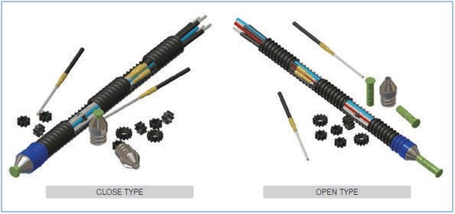
A ground anchor consists of three main parts: a head, a tendon and a root. The anchor tendon transfers tensile force deduced on the anchor head into the root, which is clamped by grouting in the ground.

the distribution of anchoring forces in the ground and are cho - sen according to the actual geotechnical conditions on the ba - sis of knowledge about the static scheme of an anchored con - struction and construction composition of a bundle of anchors.
Permanent Anchor
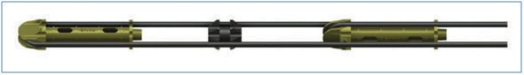

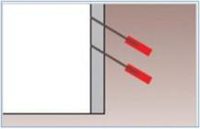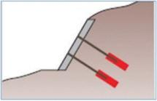
-

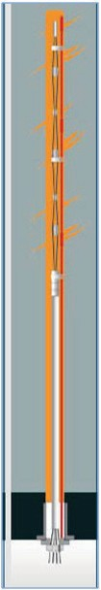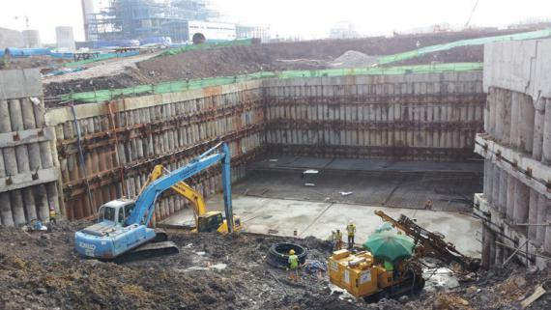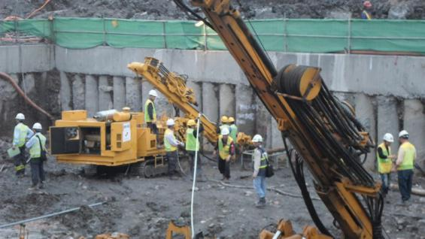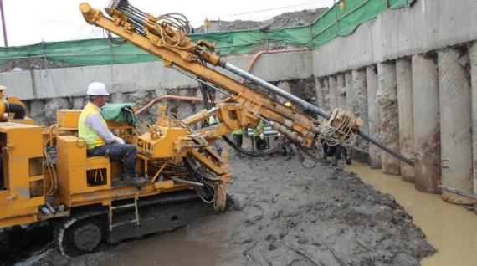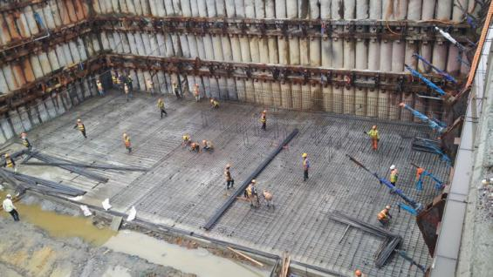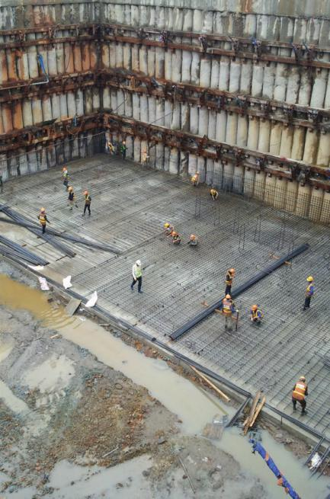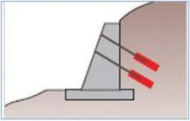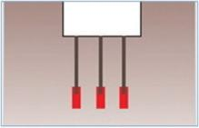Retaining Wall

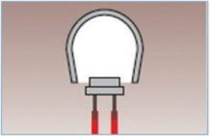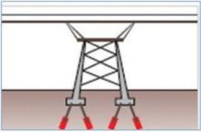Slope Retaining Wall

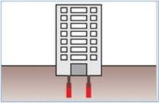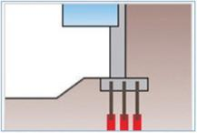Ground of Tunnel

Building Tiedown
Slope Stabilization

-
Uplift Slab
-

Structure Stabilization
-

-
Depending on the support method of ground, it can be di vided into frictional type anchor, pressure type anchor and complex type anchor. Frictional type anchor is supported by friction between grout and ground, and thus further cate gorized into tensioning anchor and pressing anchor, by the way the load is applied on the grout. Based on the load dis tribution, it can be divided to load-centric type anchor and load-distributing type anchor.
Temporary anchor is widely used to temporarily support soil-cement blocks or ground, while permanent anchor is for stabilization of slopes or prevention of roll-over and damag es of permanent structures.
Type of Anchor

Ground anchor can be categorized by service period, sup porting method, installation angle or injection, pressing method of grout material. Depending on the service period, anchors are divided into temporary anchor and permanent anchor.

Bridge Stabilization

BUSINESS AREA
GROUND ANCHOR

ancnorage plate

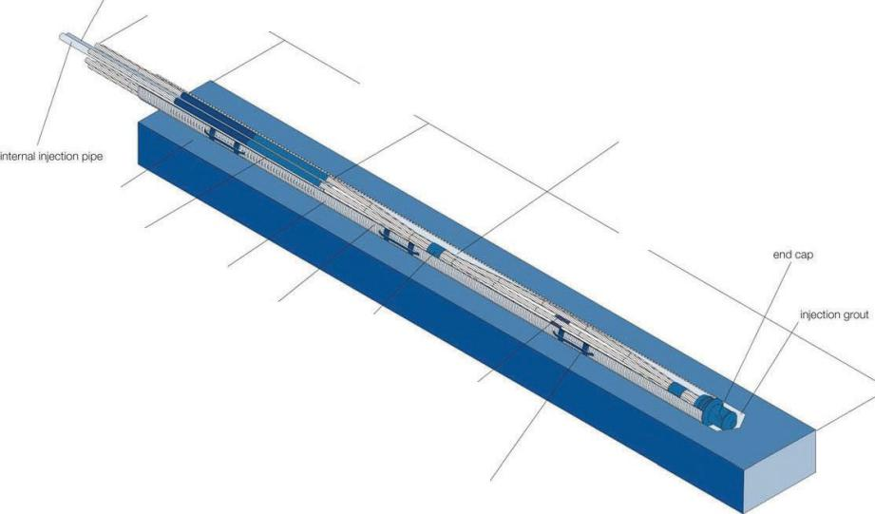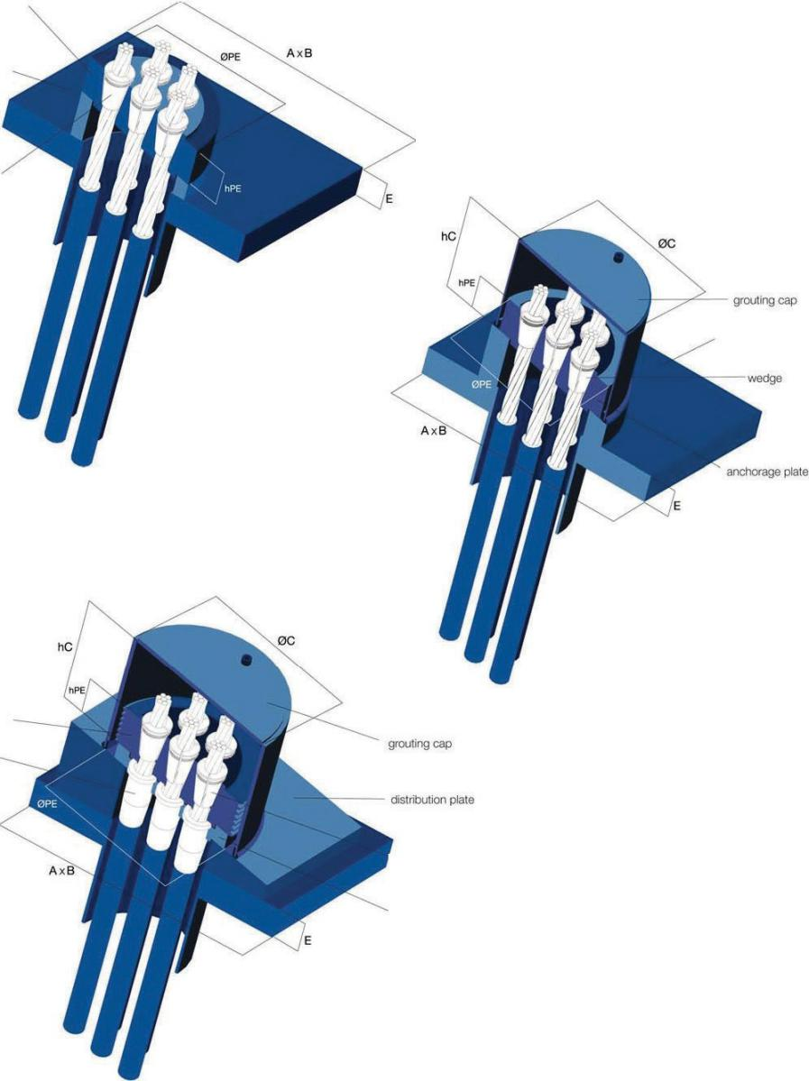distribution plate

wedge

TEMPORARYANCHOR HEADS

“RESTRESSABLE”BEARING PLATE

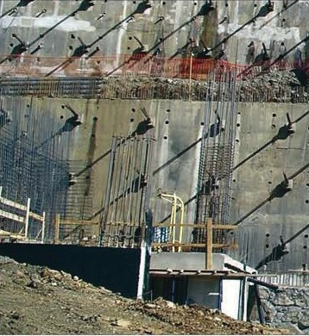distribution

anchorage plate

thimble

PERMANENT GROUND ANCHORS PARTS
external injectionpipe
stressingoverlength

noadherent freelength

'- wedge

diapl1ragm plate

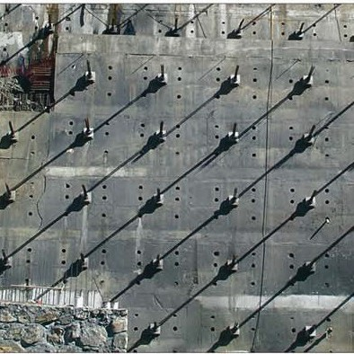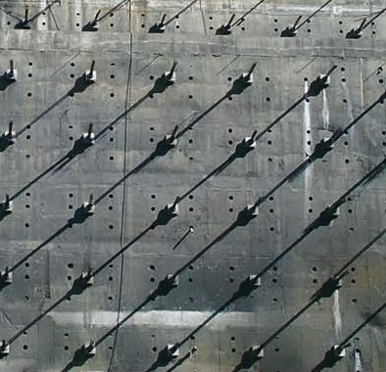“RESTRESSABLE”BEARING PLATE
Injectiongrout

borehole

polyethylene duct

corrugated duct

adherent strand

centraliser

xedlength

internalspacer

spacer

TEMPORARY GROUND ANCHORS PARTS
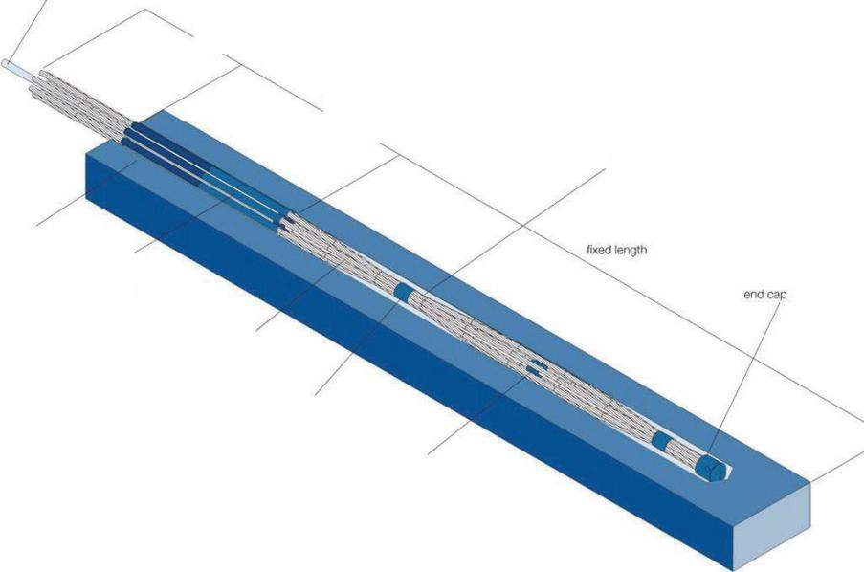injectionpipe
stressingoverlength
no adherentfree length
Injectiongrout
boreho e
polyethylene duct
adherentstrand
centraliser
internalspacer

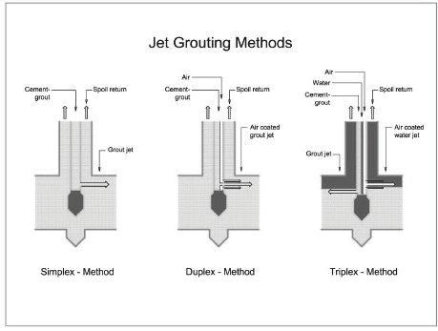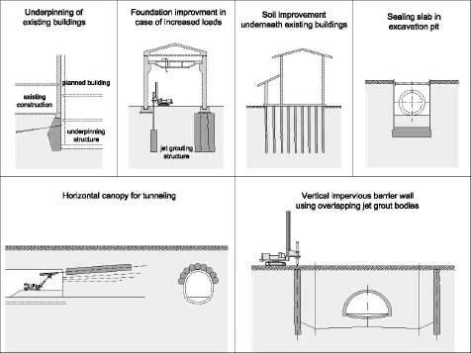BUSINESS AREA JET GROUTING
-
-
Applications of Jet Grouting

t VOEFSQJOOJOH of existing structures
t downward extension of foundations in the case of settlements or
increased load
t soil improvement, even underneath existing struc tures
t WFrtical impervious barriers
t JNQFSNFBCMF CBTF for excavations
t bracing and stiffening of excavations underneath their base
t connection of sealing walls to existing structures and/or services
and utilities
t XBMMT for cylindrical or polygonal excavations
t IPSJzontal screens and canopies for tunnelling
t soil stabilisation between neighbouring excava tions or foundation
works
t impervious connection of individual piles in pile walls
-

Jet Grouting or High Pressure Grouting can be employed in all soils from clays to coarse gravels irrespective of grain size distribution, void ratio or pore sizes. Jet grouting uses a high pressure jet (approx. 400 bar) to cut the
jet grouting:
Simplex-Method
Cement grout is injected into the soil with high pres sure (approx. 400 bar) at the drill head (monitor). The jet cuts the soil and mixes it thoroughly with the grout. The Simplex-method is appropriate for shal low depths and horizontal jet grouting.
Duplex-Method
Using special rods with double inner conduit (Duplex string) compressed air is introduced into the grout jet at its exit point. This adds energy and enables the Duplex-method to reach much greater depths and achieve larger diameters than the Simplex-method. Triplex-Method
The Triplex-method uses a high pressure water jet with compressed air to cut the soil. Cement grout is introduced into the soil and mixed with it through a separate jet nozzle situated just below the jet nozzle for the water (Triplex string with triple inner conduit rods). The Triplex-method is an appropriate method for underpinning, especially in cohesive soils.
Jet Grouting Methods
natural soil in order to mix and partially replace it with the grout. This cre - ates a “soilcrete” body whose strength and/or permeability characteristics
-
are independent of the original soil fabric.

-

Dimensions
Different geometric forms and dimensions of the soilcrete body can be produced with jet grouting: t without rotation of the rods during withdrawal and jetting, cut-off walls of various thickness can be pro duced;
t with partial rotation, segments of a cylinder can be produced (bow-tie);
t with full rotation, a cylindrical body is produced; diameter of the cylinder can be changed by varying withdrawal rate and/or jet pressure.

Jet Grouting Parameters

Jet grouting parameters which are chosen for a given project depend on the required characteristics of the

the soil and the chosen jetting method. Principle jet grouting parameters are:
t withdrawal rate of the jet string t rotation speed of

t KFU QSFTTVSF t KFU WPMVNF
t OVNCFS BOE EJBNFter of jet nozzles
t volume and pressure of compressed air t mix de sign of the grout
-

BUSINESS AREA JET GROUTING
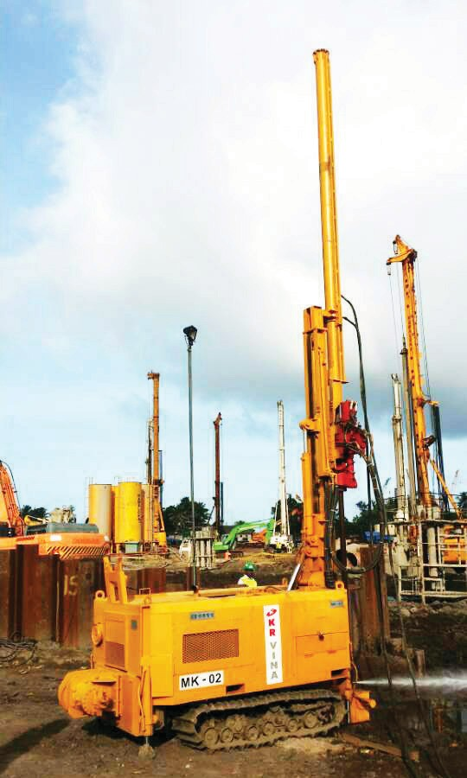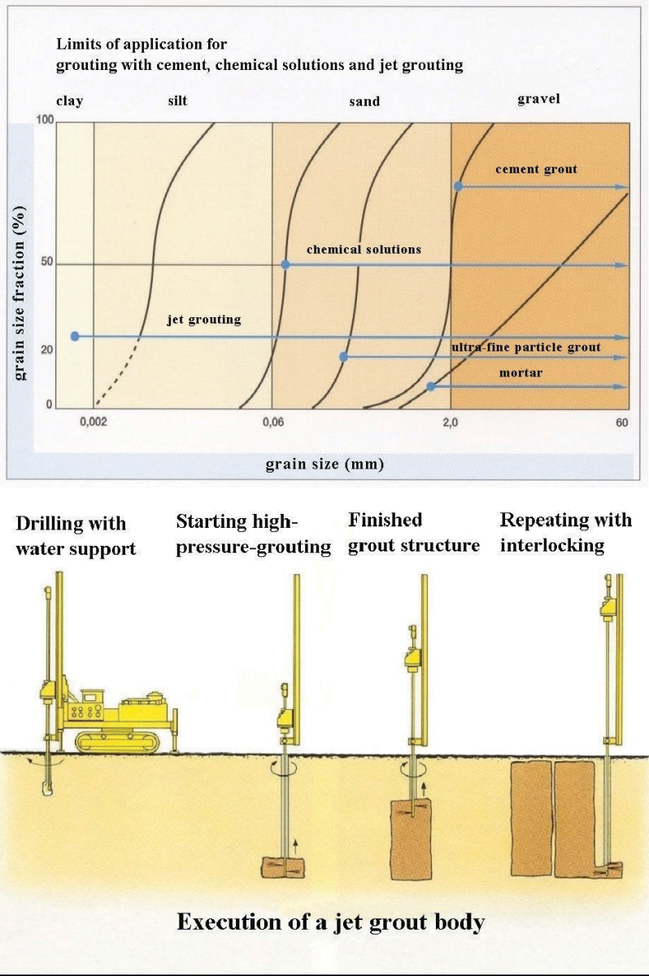

high pressure jet
-
jet pressure, withdrawal rate and rotation of the jetting gear.

onto the ground surface. This spoil is collected and removed. All materials used in the jet grouting process – water, cement, occasionally bentonite and the soil -- are natural inert materials
which have no negative impact on groundwater and environ ment.
Jet grouted columns can be executed as vertical columns or in any inclination.
To construct a jet grouted column, a small diameter bore is drilled with the jet rods and drill bit down to the design depth.

soil type. To increase the diameter of the jet grouted column and

very compact soils, pre-cutting with high pressure water may be employed during the initial drilling.

As soon as the design depth has been reached, the rods and drill bit are slowly withdrawn from the soil. During the withdrawal, grout is injected at high pressure (approx. 400 bar) into the soil from jet nozzles which are situated horizontally just above the bottom of the drill bit. The speed of particles in the jet is approx. 200m/s. Because the drill rods and drill bit are kept rotating during withdrawal and jetting, a homogenous cylindrical body is produced consisting of a mix of injected grout and displaced soil.

limits of applicatio n for grouting methods

schematic execution of a jet
g rout body

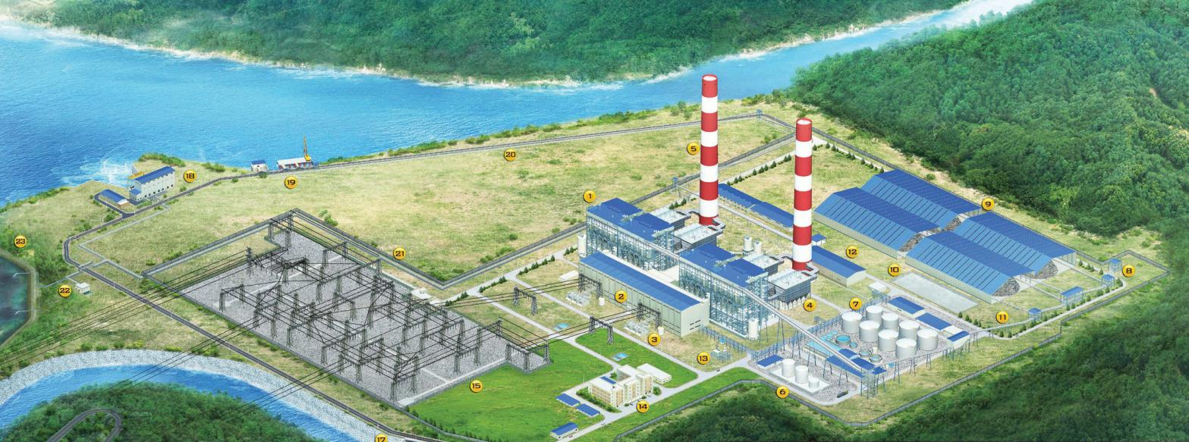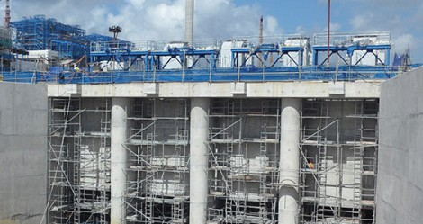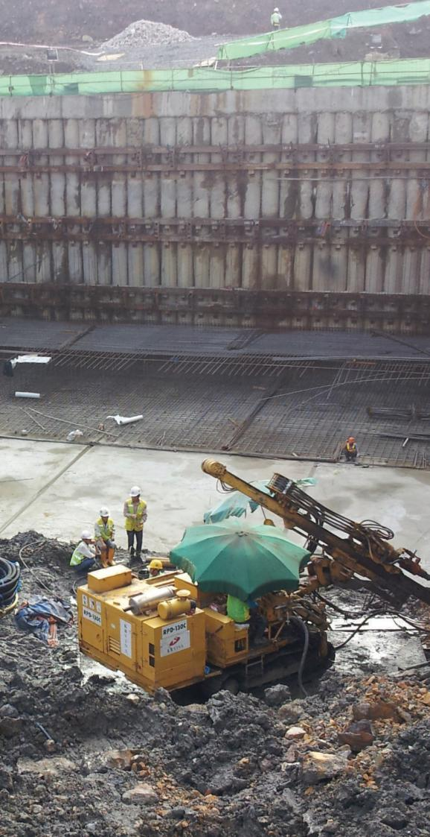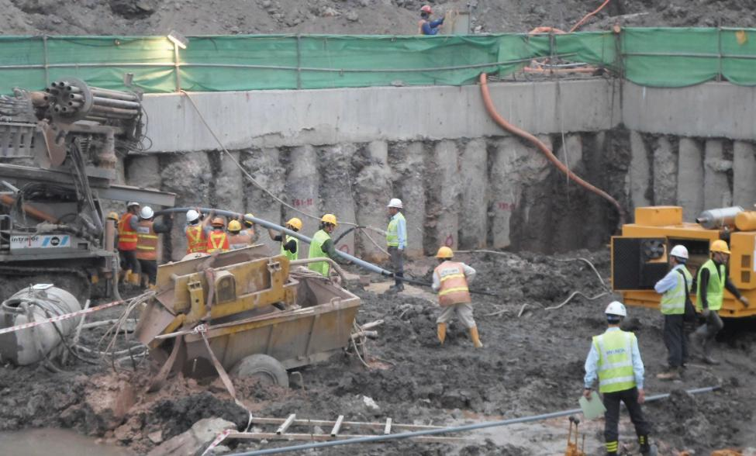PROJECT LIST
Performance I

PROJECT SUMMARY

MONG DUONG I COAL FIRED POWER PROJECT– DOOSAN E&C- HYUNDAI E&C

Location: Mong Duong, Cam Pha, Quang Ninh

Work Scope: Jet Grouting, Construction and Completion of Temporary Ground Anchor for Pump house and permanent Ground Anchor for Fore bay area (wing wall)
Jet grouting Diameter/ Length: 600mm/ 5,523m Anchor type: Permanent Anchor 15.4mm X 5 Tension Load: D 50~65 Ton / J 55~73 Ton
Length / holes: 5,277 M / 226 holes
Geological Conditions: Weathered rock & siltstone Volume: 3,042m 3
Geological Conditions: Clay sand & clay

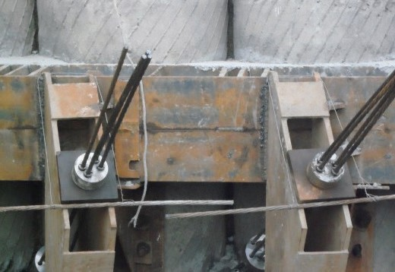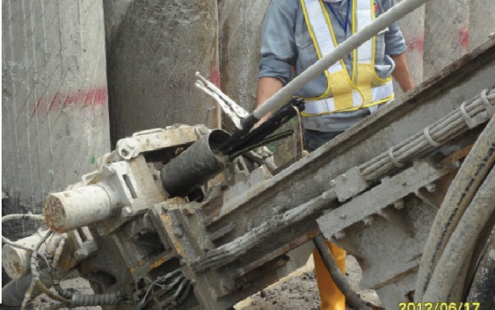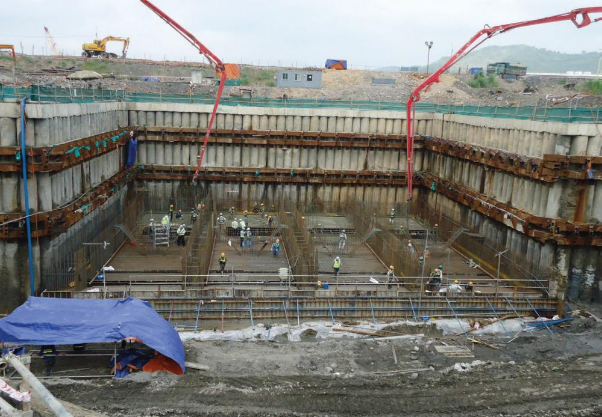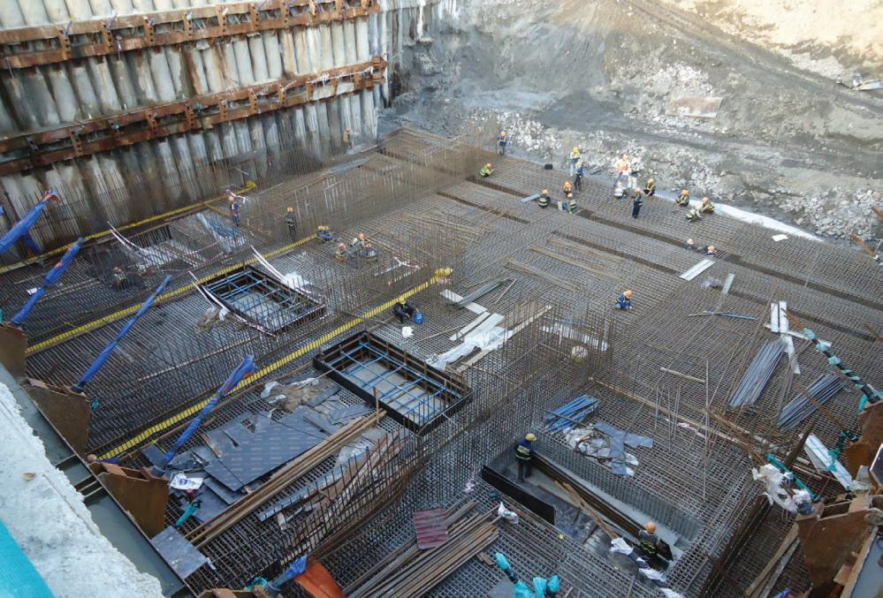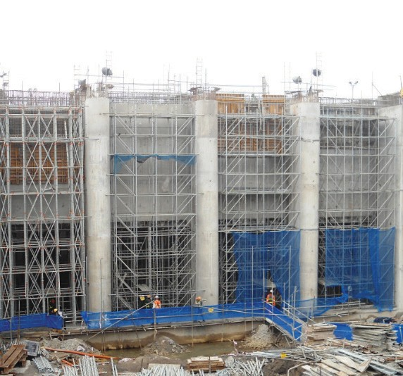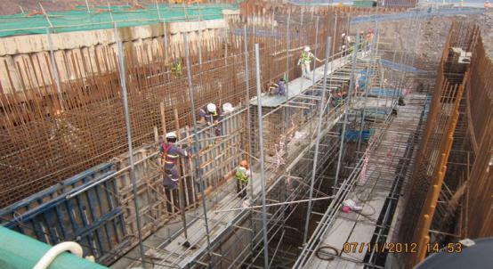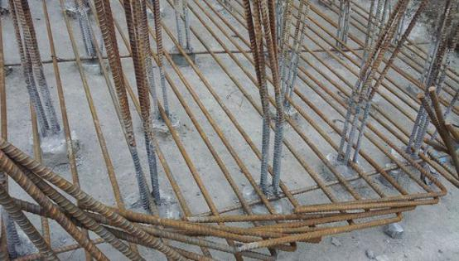PROJECT LIST
Performance 2

PROJECT SUMMARY

MONG DUONG II COAL FIRED POWER PROJECT– EPC: DOOSAN HEAVY INDUSTRY

Location: Mong Duong, Cam Pha, Quang Ninh

Work Scope: Construction and Completion Temporary Work for Intake Pumping station
Micro Pile type: Steel bar 19mm x 4 Design Load: 25 TON
Length/ Holes: 4,373 M / 1,98 holes x D 200mm\

Anchor type: Temporary anchor 15.2 x 4 Tension Load: D 41 Ton / J 49 Ton Length / Holes: 1,825 M / 86 holes
Bore pile continuous retaining wall D800 26m Length Geological Conditions: Weathered rock & siltstone

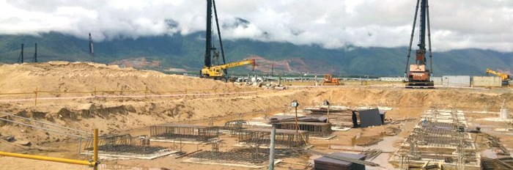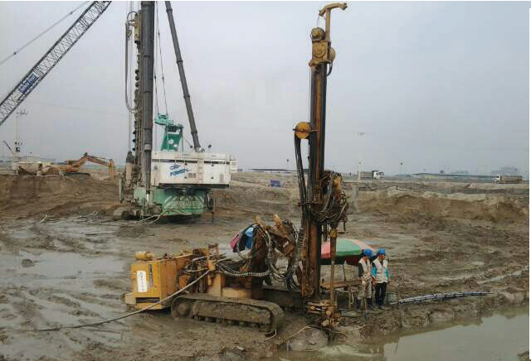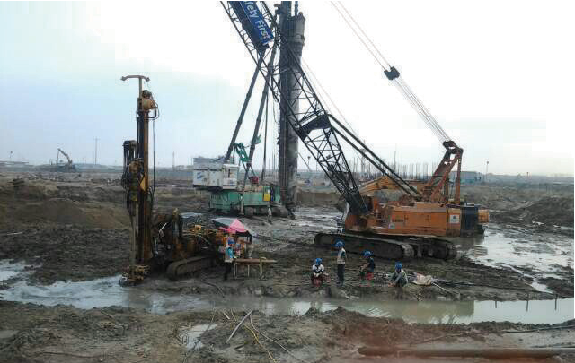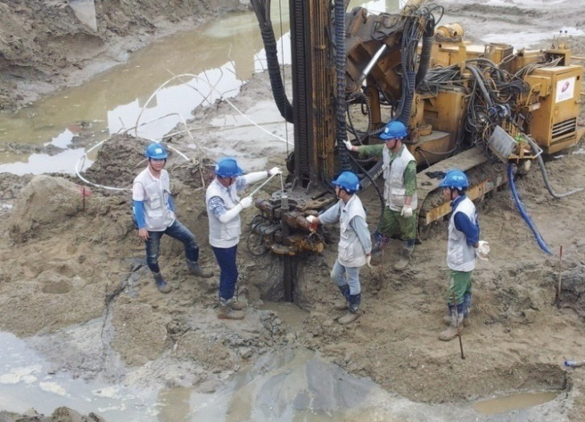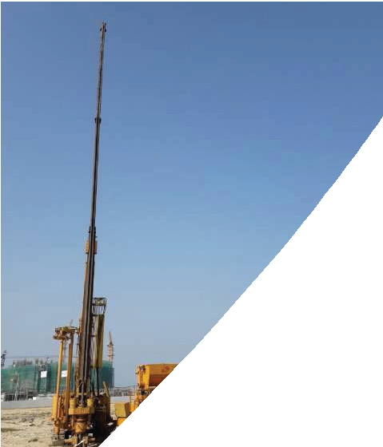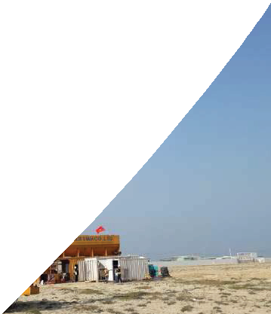PROJECT LIST
Performance 3

PROJECT SUMMARY FOMOSA HA TINH PROJECT-POSCO E&C

Location: Ky Anh, Hà Tinh
Work Scope: LW Grouting - impermeable wall
Diameter / Length: 600 mm / 4,211 m Volume: 1,079 m3
Geological Conditions: Clay sand & clay

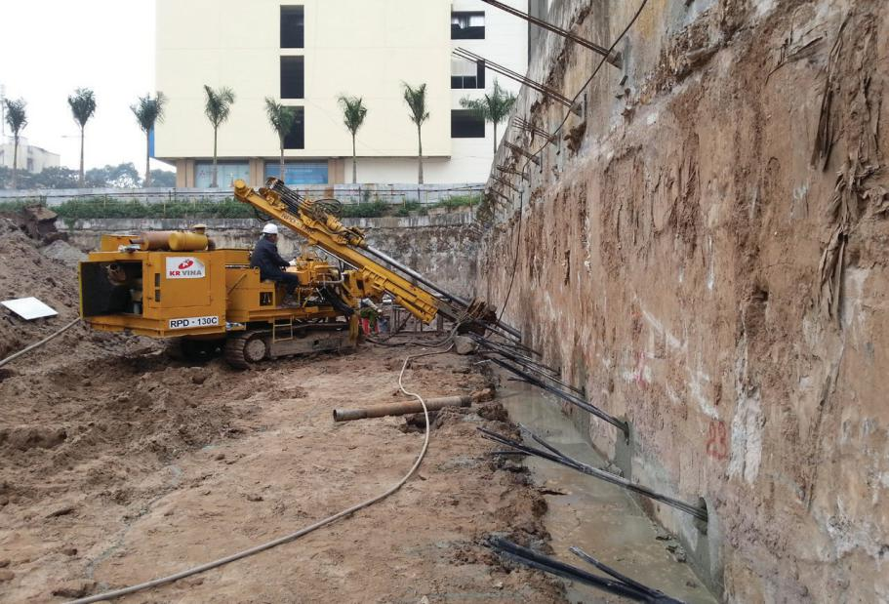
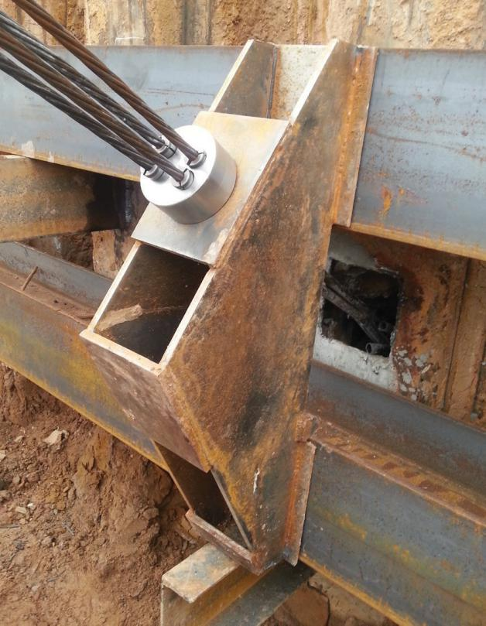
PROJECT LIST
Performance 4

PROJECT SUMMARY

BOOYOUNG VINA PROJECT

Location: Mo Lao, Ha Dong, Ha Noi

Underground work: Ground Anchor, sheet pile, D-wall, Bored pill - ing work for CT04, CT07.
Anchor type: Temporary anchor 12.7 x 4 ea Tension Load: D 20 ton / J 25 Ton
Length / Holes: 5,952 M / 326 holes Geological Conditions: Clay sand & clay

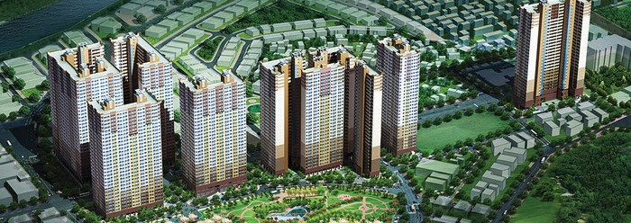

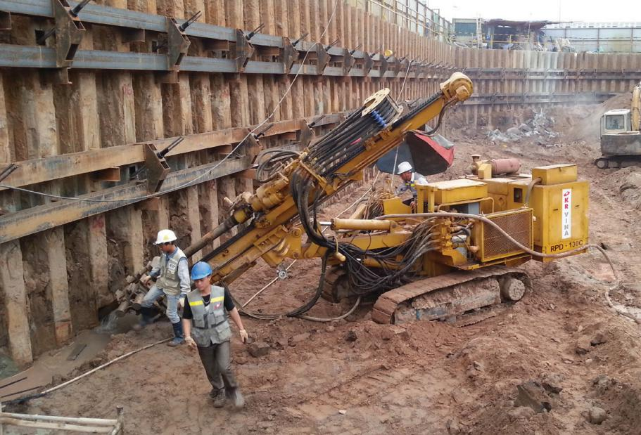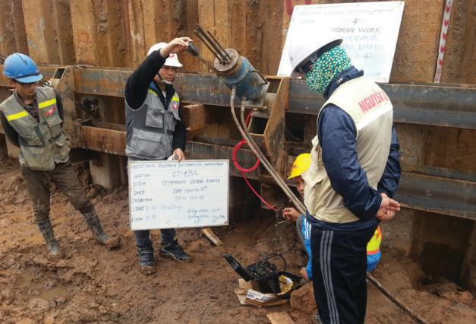

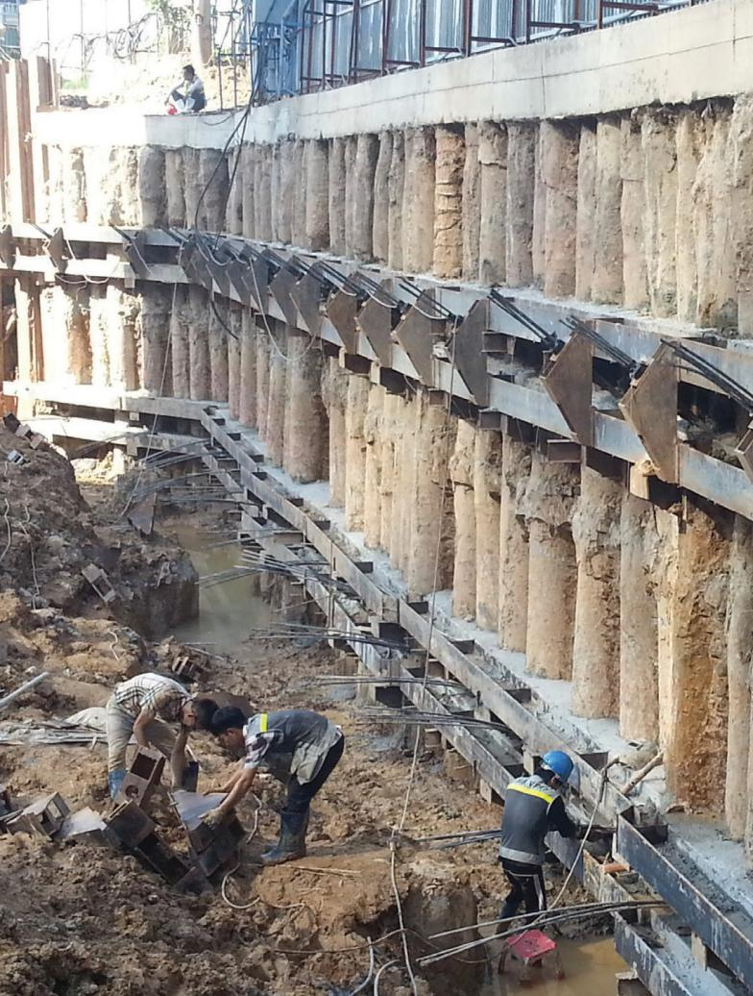PROJECT LIST
Performance 5

PROJECT SUMMARY

THE GARDEN HILL PROJECT

Location: 99 Tran Binh, Nam Tu Liem, Ha Noi Underground work: Ground Anchor Anchor type: Temporary anchor 12.7 x 4 ea Tension Load: D 25 ton / J 25 Ton
Length / Holes: 1,000 M / 50 holes Geological Conditions: Clay sand & clay

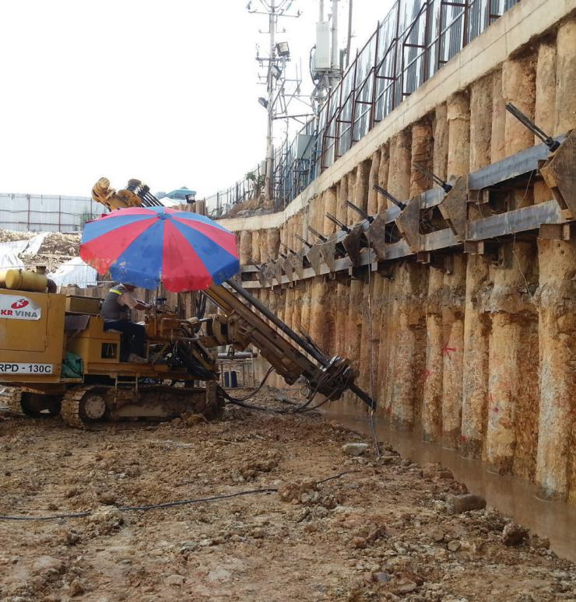
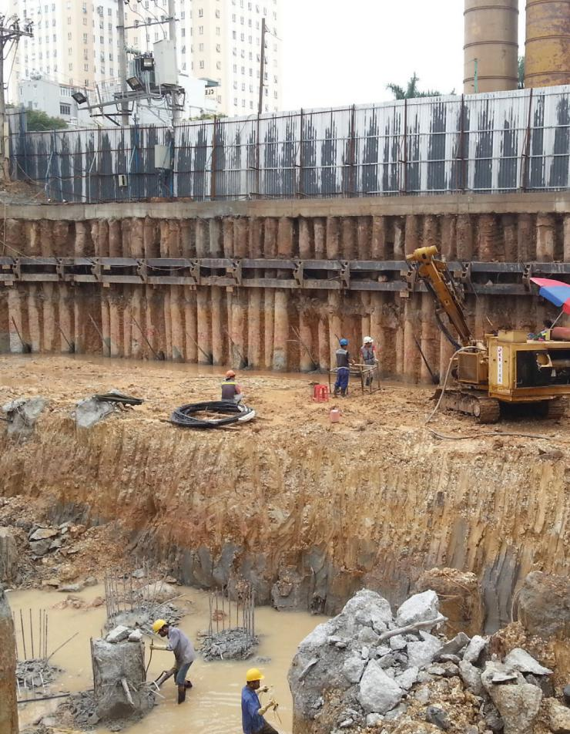
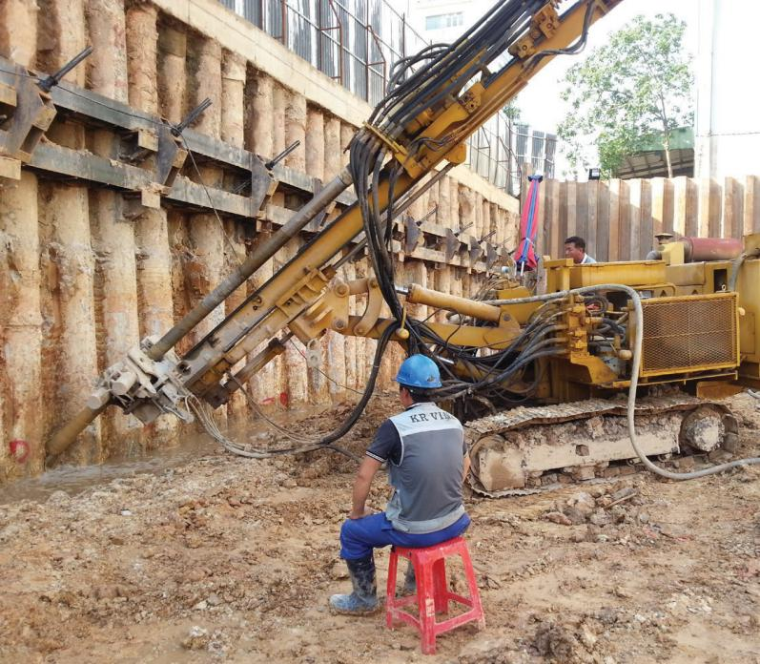

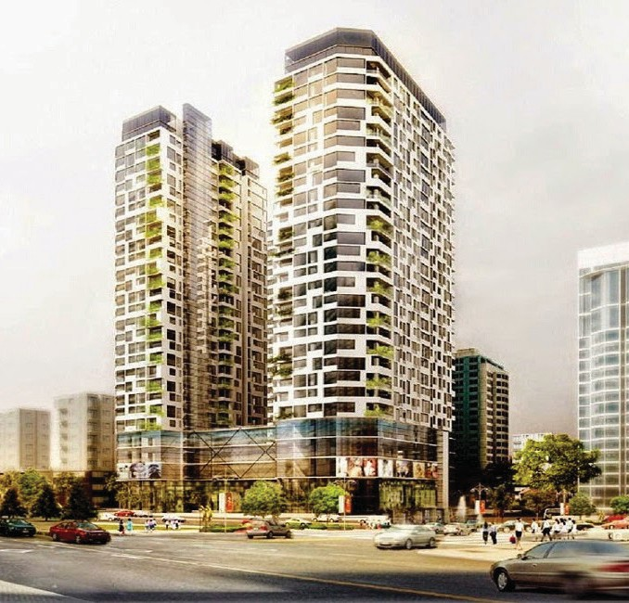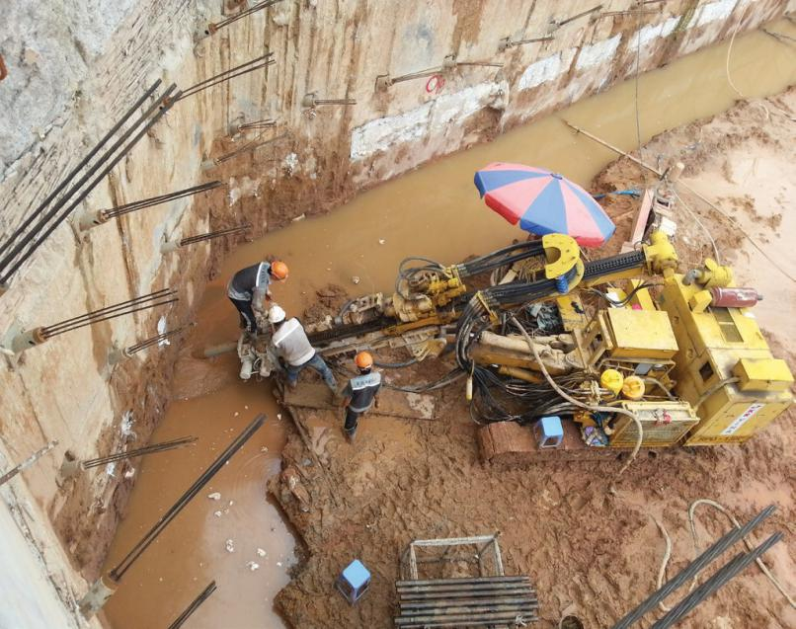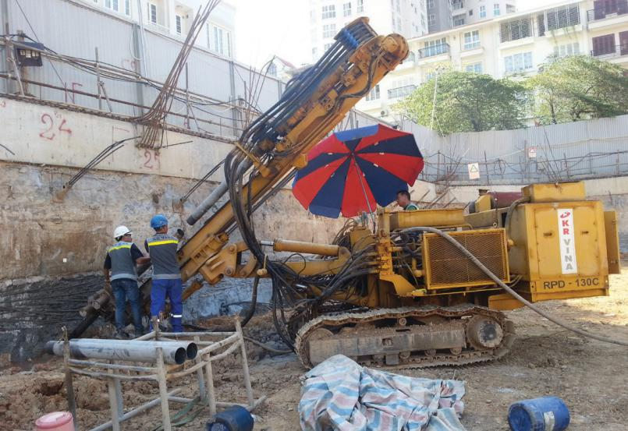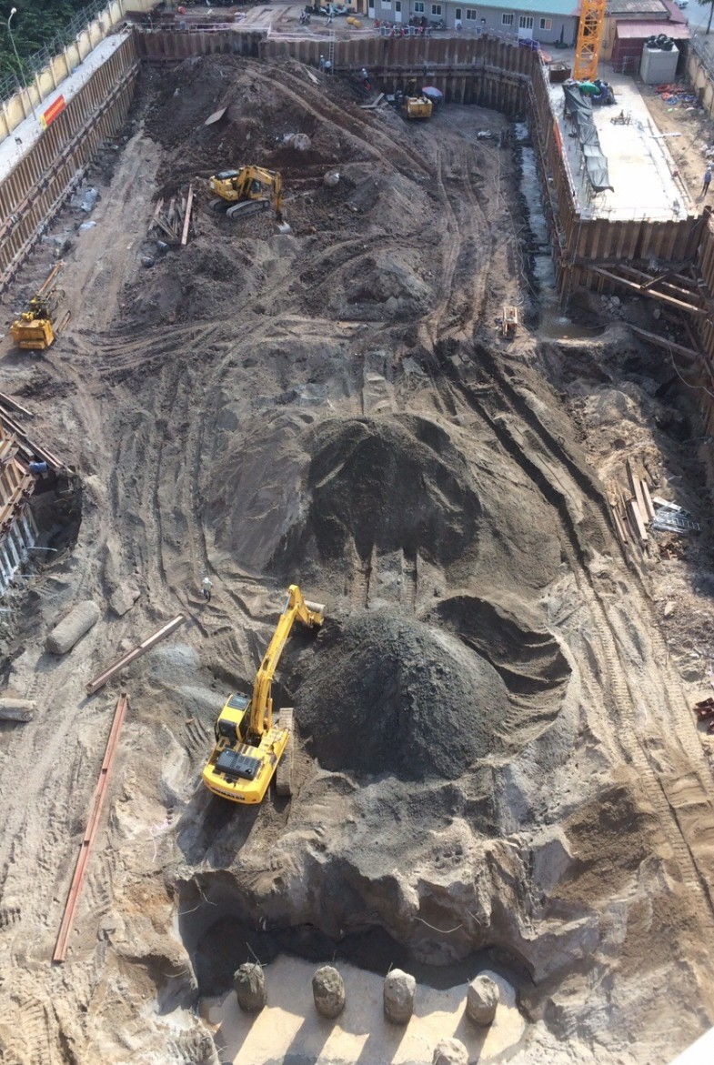PROJECT LIST
Performance 6

PROJECT SUMMARY

219 TRUNG KINH PROJECT

Location: Trung Kinh, Trung Hoa, Cau Giay, Ha Noi

Work Scope: Construction and Completion of Ground Anchor work
Anchor type: Temporary anchor 15.2 x 4 Length / Holes: 4000 m / 200 Geological Conditions: Clay sand & clay

PROJECT LIST
Performance 7

PROJECT SUMMARY

WATERFRONT PROJECT

Client: John Keells Holdings
Sri Lanka’s John Keells Holdings has awarded a consortium
led by South Korea’s Korea’s Hyundai Engineering and Con - struction, a 522 million US dollar contract to build an in - tegrated resort, a media report said. Hyundai E&C has a 65
percent stake in the construction consortium (339 million
US dollars), Keangnam Enterprises, another Korean build - er 25 percent (130 million) and the balance by Sri Lanka’s
Nawaloka, Korea’s Yonhap news agency said.

The resort is built by Waterfront Properties, a unit of John Keells Holdings. Waterfront properties is one of two high

Lanka’s tourism product.

projects, with foreign debt funding also expected to come in. JKH stock was quoted at 219 rupees up 20 percent in mid morning trade.

Location: Sri Lanka
Scope of work: Construction and Completion for Foudation

work including jet grouting, sheet pilling, CDM, steel sup - porting system

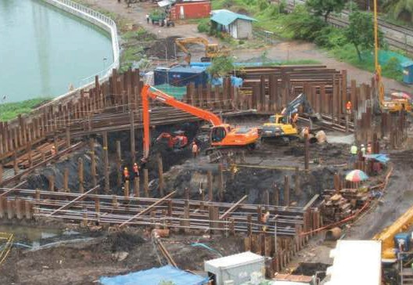
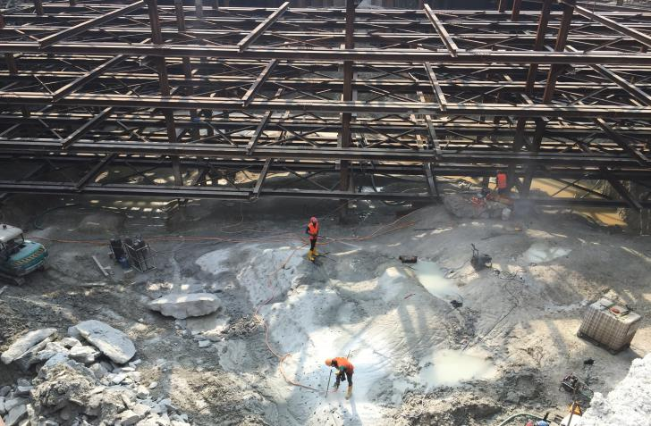

PROJECT LIST
Performance 9

PROJECT SUMMARY

YANGON INNO CITY DEVELOPMENT PROJECT
Client: Inno International Development Co.,Ltd.
Construction Company: A SEUNG Global E&C
Location: Corner of Parami and Wayzayandar Roads, South Okkalapa Township, Yangon, Myanmar.
Work scope: Construction and Completion of Ground Anchor work.
Anchor type: Temporary anchor 12.7*4
Length / Holes : 4,592 M / 260 holes
Geological condition: Clay, sand, stone a bit.

PROJECT LIST
Performance 10

PROJECT SUMMARY

Center West of West Lake Town PROJECT
Client: T.H.T Development Co.,Ltd.
Construction Company: WOOKYUNG Construction
Location: Center West of West Lake town, H9 plot-CT1
Work scope: Construction and Completion of Ground
Anchor, Beam and Monitoring
Anchor type: Temporary anchor 12.7*4
Length / Holes: 9162 M / 434 holes
Geological condition: Clay, sand, stone a bit.

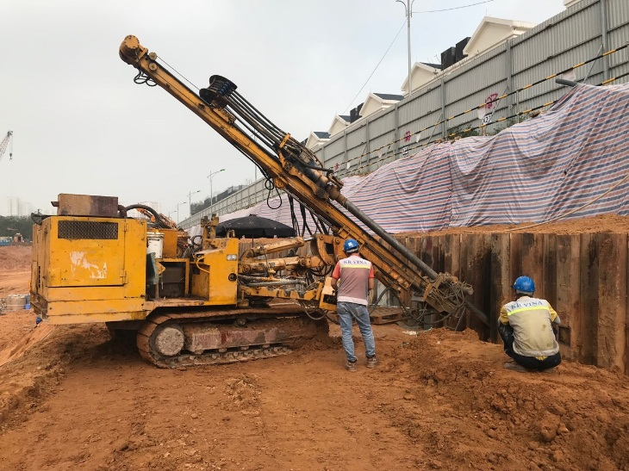
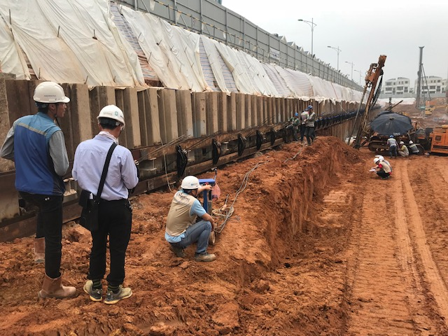

S
1

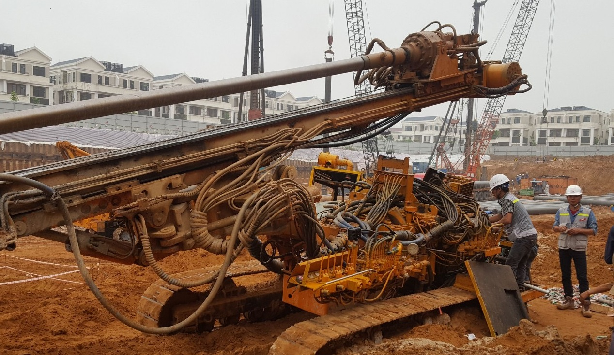

PROJECT LIST
Performance 11

PROJECT SUMMARY

NAM THEUN 1 HYDROPOWER PROJECT
Client: Phonesack Group i.e. Nam Theun 1 Hydropower Company
Construction Company: CMC/ITD/SONG DA JOINT VENTURE
Location: Ban Phone Ngarm, Pak Kading district, Bolikhamxay province, Lao PDR
Work scope: Construction and Completion of Tendon Anchor, Monitoring
Anchor type: Permanent anchor PTF 15.24 * 5
Length / Holes: 1350 M / 90 holes
Geological condition: Rock

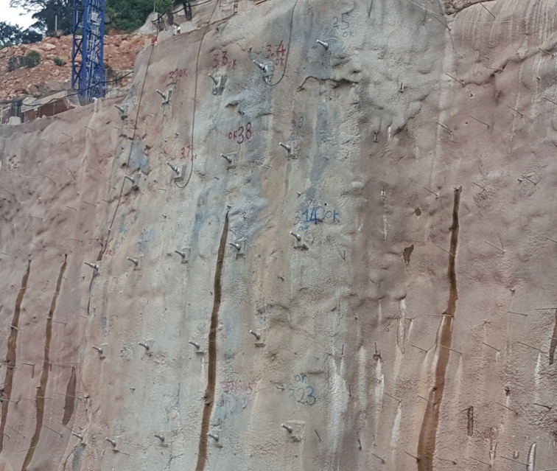
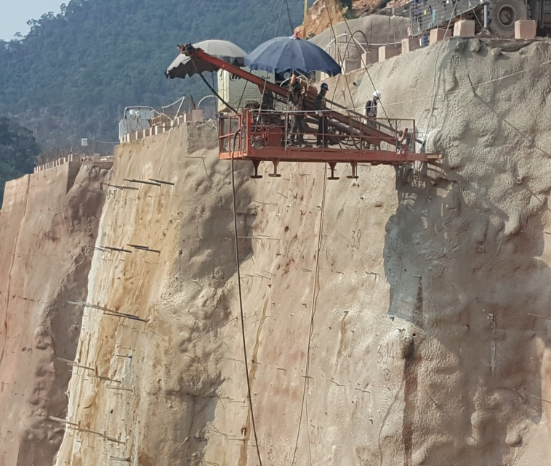

S
1

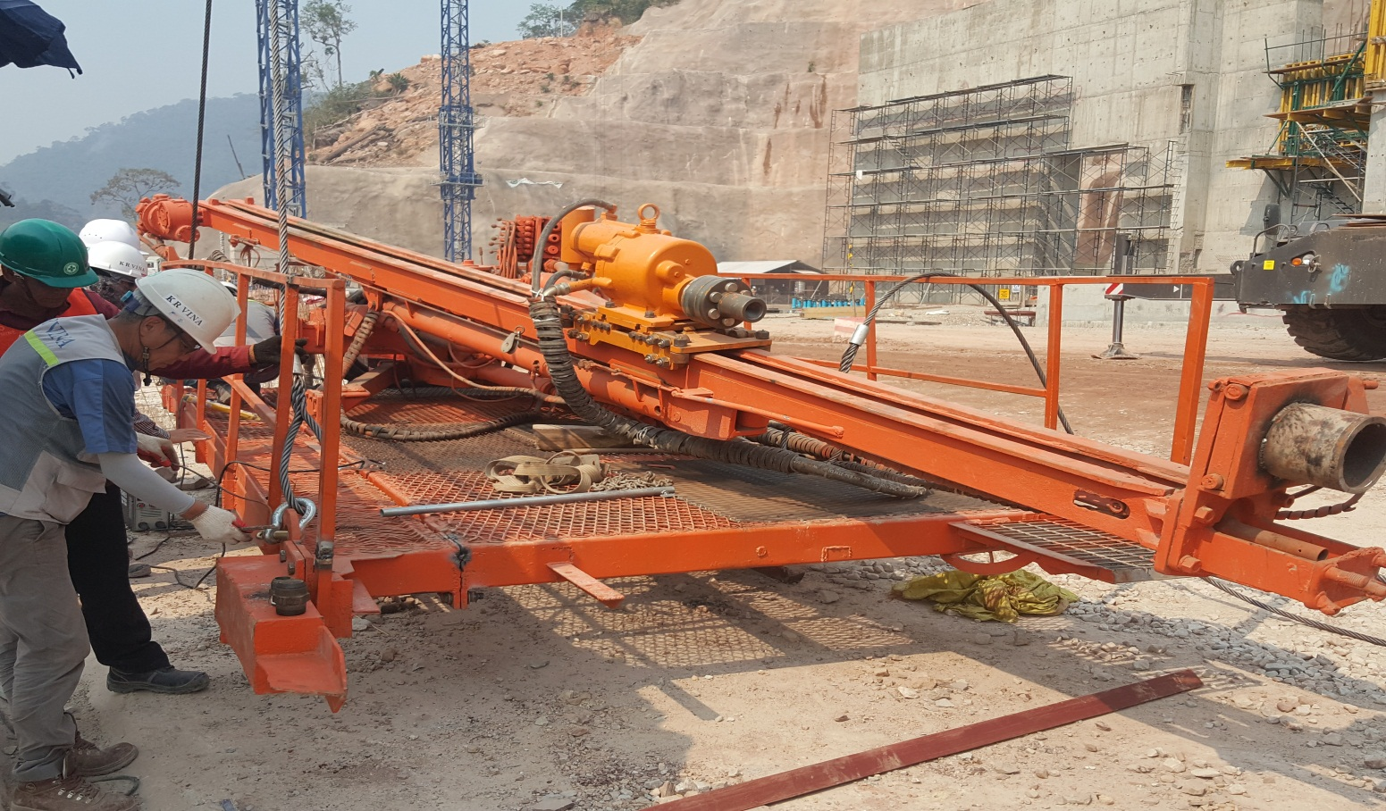

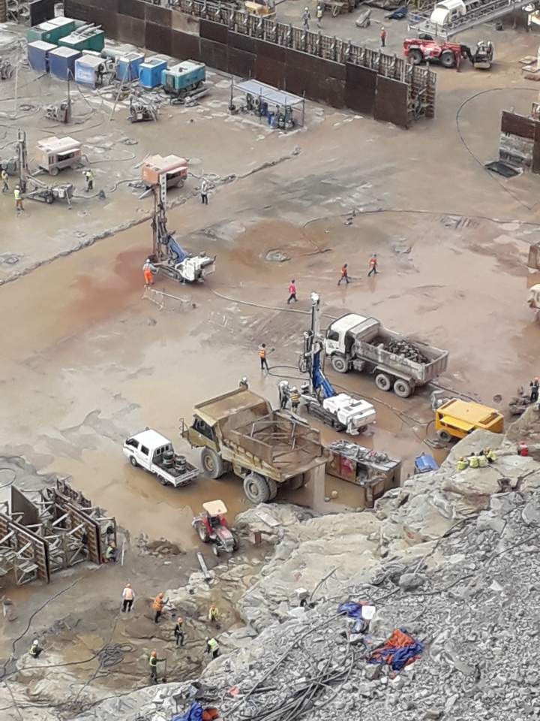
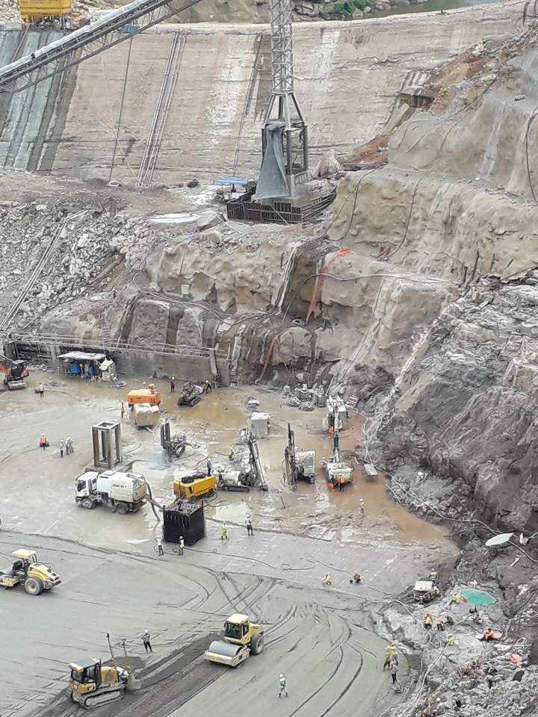

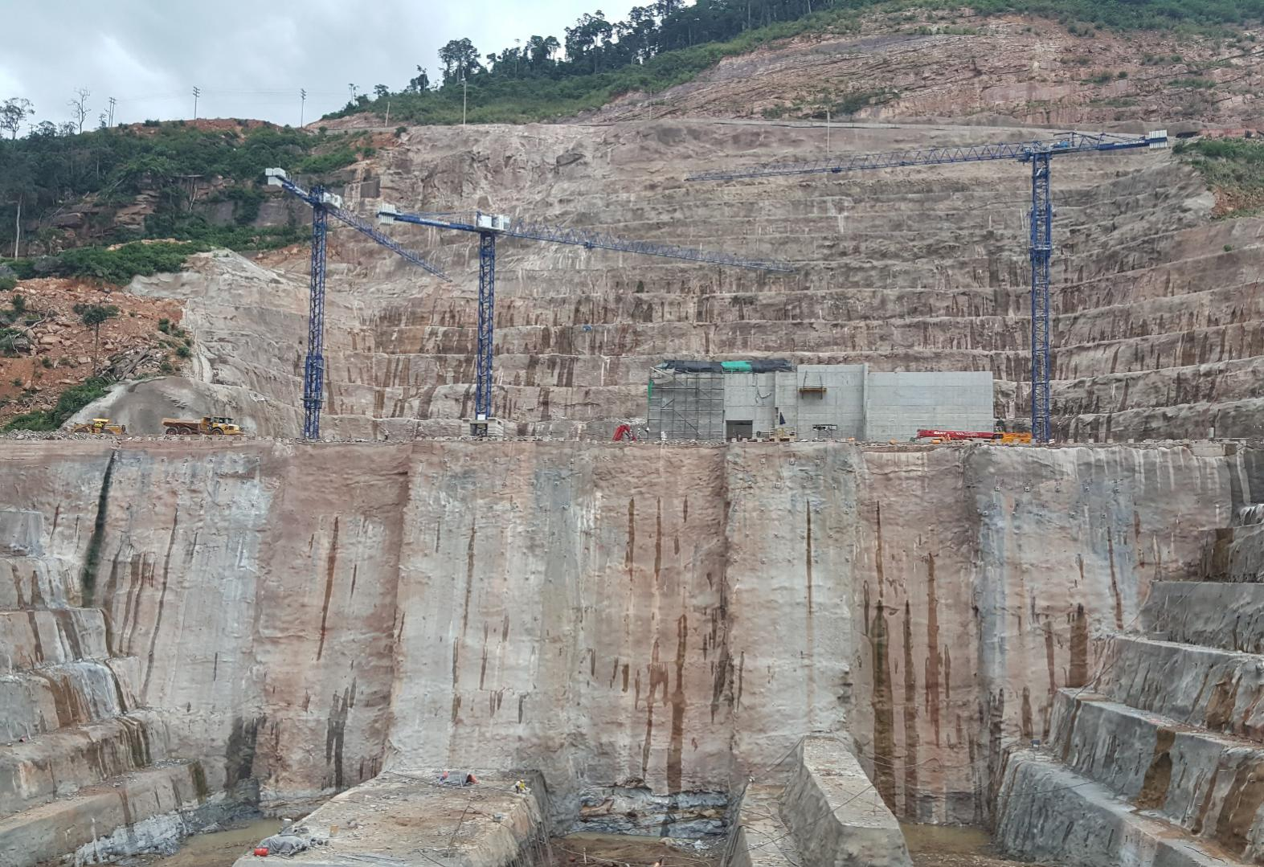

PROJECT LIST
Performance 12

PROJECT SUMMARY

LOTTE MALL HA NOI PROJECT
Client: LOTTE
Construction Company: WOOKYUNG Construction and

FECON CORPORATION
Location: Nhat Tan and Phu Thuong Ward in Tay Ho
District, Ha Noi city, Viet Nam.
Work scope: Construction and Completion of Ground
Anchor, Beam.
Anchor type: Removable anchor 12.7*4 w
Length / Holes: 31552M / 1679 holes
Geological condition: Clay

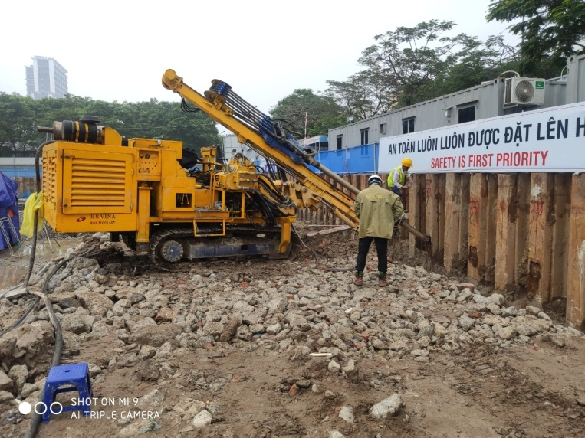
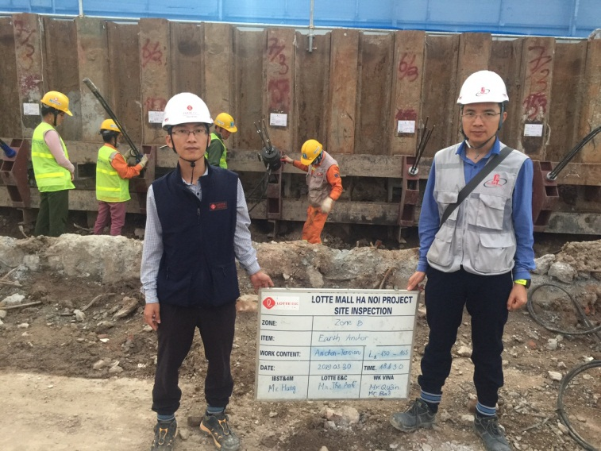

S
1

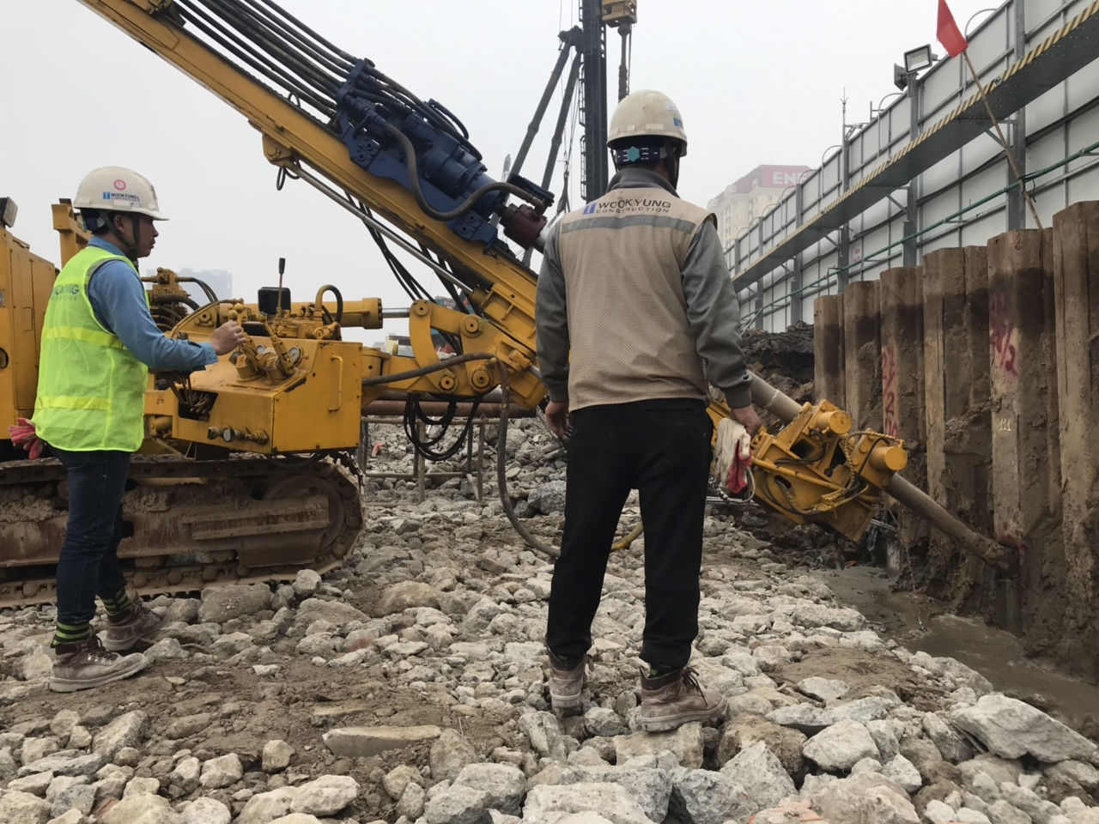

BUSINESS AREA MICRO PILE
A micropile is a slim foundation component that transfers ax - ial loads (both compressive and tensile) from a structure into
deeper and better bearing layers of foundation soil.

In principle, they are bored piles of up to 300 mm in diameter use of micropiles is especially suitable in cases of foundation
works and their foundations, underpinning of existing founda - tions or securing drivings of underground works.

A micropile consists of three components: a head, which takes
over the load of the building construction, a shaft that normal -
surrounding rock and transferring the building construction load on it.

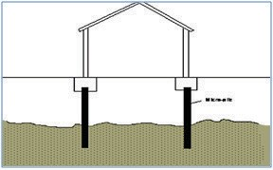
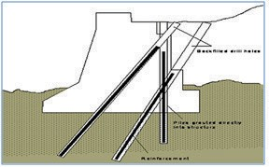
Application of Micro Pile
Bearing piles Soil retaining & Reinforcement
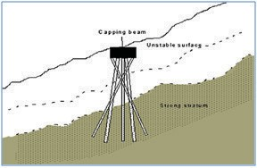
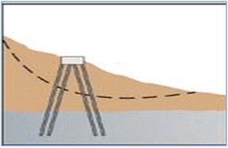
Intension piles Reticulated pile wall

Execution phases of Micropile

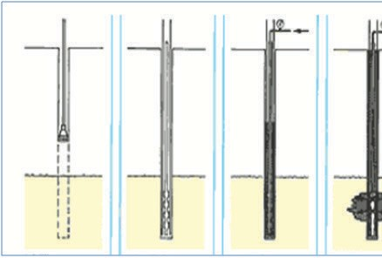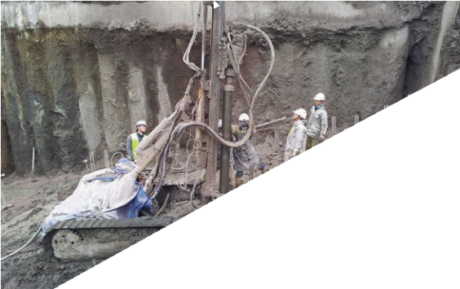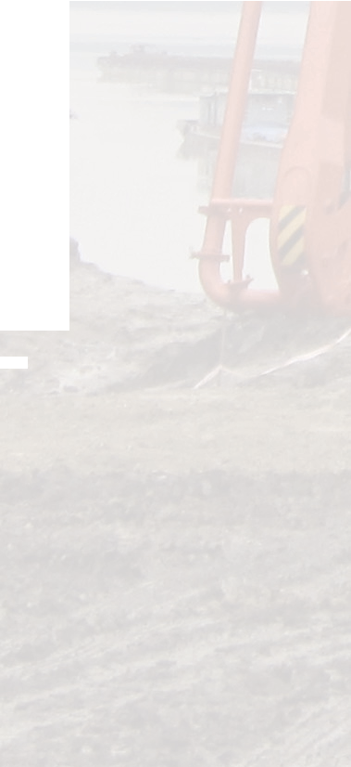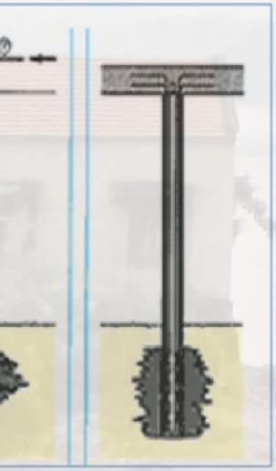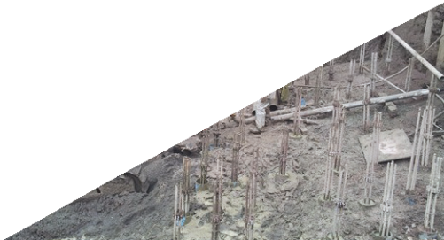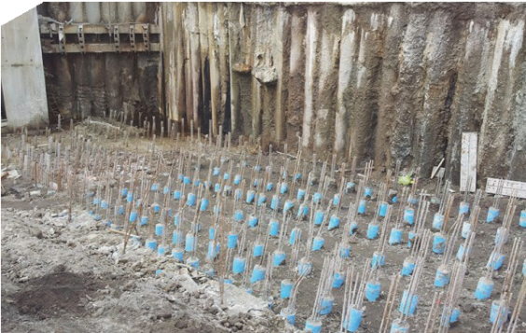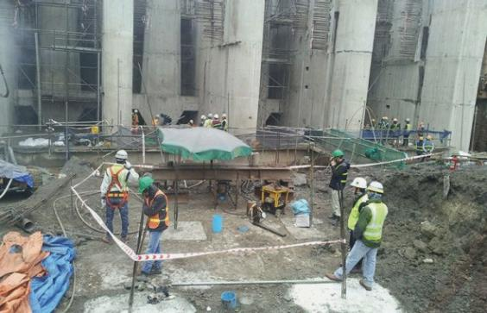Drilling Insert
hase
Install the head
part.
Micropile
Initial Grouting
Second p Grouting – packer by packer
n a he he d

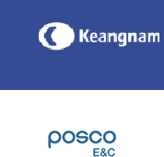

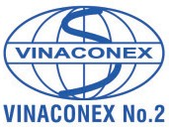
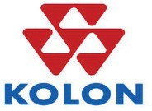
$ 6(81*

